**Installation**

You're first going to need to install the Angular CLI (Command Line Interface) tool, which helps you start new Angular 7 projects as well as assist you during development. In order to install the Angular CLI, you will need [**Nodejs**](http://nodejs.org/). Make sure you install this with the default options and reload your command line or console after doing so.

In your command line, type:

> npm install -g @angular/cli

Once complete, you can now access the CLI by simply starting any commands with **ng**.

Hop into whichever folder you want to store your projects, and run the following command to install a new Angular 7 project:

> ng new ng7-pre

It's going to present you with a couple questions before beginning:

? Would you like to add Angular routing? Yes

? Which stylesheet format would you like to use? SCSS [ [**http://sass-lang.com**](http://sass-lang.com/) ]

It will take a minute or two and once completed, you can now hop into the new project folder by typing:

> cd ng7

Open up this project in your preferred code editor (I use Visual Studio Code, and you can launch it automatically by typing *code .* in the current folder), and then run this command to run a development server using the Angular CLI:

> ng serve -o

**-o** is for *open*, this flag will open your default browser at [***http://localhost:4200***](http://localhost:4200/). **Tip:** You can type **ng** to get a list of all available commands, and **ng [command] --help** to discover all their flags.

Awesome! If all went smooth, you should be presented with the standard landing page template for your new Angular 7 project:

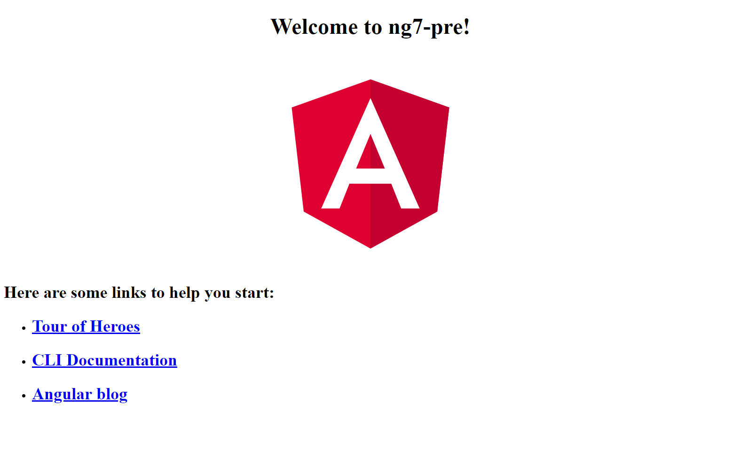

**Angular 7 Components**

The most basic building block of your Angular 7 application (and this is a concept that's not new) is the component. A component consists of three primary elements:

* The HTML template
* The logic
* The styling (CSS, Sass, Stylus, etc..)

When we use the Angular CLI to start a new project, it generates a single component, which is found in **/src/app/**:

/app.component.html

/app.component.scss

/app.component.ts

While we have three files here that represent the three elements above, the **.ts** (TypeScript) is the heart of the component. Let's take a look at that file:

import { Component } from '@angular/core';

@Component({

selector: 'app-root',

templateUrl: './app.component.html',

styleUrls: ['./app.component.scss']

})

export class AppComponent {

title = 'ng7-pre';

}

Here, because this is a component, we're importing Component from the @angular/core library, and then it defines what's called a *@Component decorator*, which provides configuration options for that particular component.

As you can see, it's referencing the location of the HTML template file and the CSS file with the *templateUrl* property and the *styleUrls* property.

The logic of the component resides in the class at the bottom. As you can see, the CLI starter template simply defines a single property called **title**.

Let's use the Angular CLI to create our own components that we'll need going forward. In the console, issue the following commands:

> ng generate component nav

// output

> ng g c about

// output

> ng g c contact

// output

> ng g c home

// output

Notice we first use the full syntax to generate a component, and then we use a shorthand syntax, which makes life a little bit easier. The commands do the same thing: generate components.

When we generate components this way, it will create a new folder in the */src/* folder based on the name we gave it, along with the respective template, CSS, .ts and .spec (for testing) files.

**Angular 7 Templating**

You may have noticed that one of the components we generated was called *nav*. Let's implement a header bar with a navigation in our app!

The first step is to visit the **app.component.html** file and specify the following contents:

<app-nav></app-nav>

<section>

<router-outlet></router-outlet>

</section>

So, we've removed a bunch of templating and placed in *<app-nav></app-nav>*, what does this do and where does it come from?

Well, if you visit **/src/app/nav/nav.component.ts** you will see that in the component decorator, there's a *selector* property bound to the value of *app-nav*. When you reference the selector of a given component in the form of a custom HTML element, it will nest that component inside of the component it's that's referencing it.

If you save the file you just updated, you will see in the browser we have a simple, *nav works!* And that's because the *nav.component.html* file consists of a simple paragraph stating as much.

At this point, let's specify the following HTML to create a simple navigation:

<header>

<div class="container">

<a routerLink="/" class="logo">apptitle</a>

<nav>

<ul>

<li><a routerLink="/">Home</a></li>

<li><a routerLink="/about">About</a></li>

<li><a routerLink="/contact">Contact us</a></li>

</ul>

</nav>

</div>

</header>

The only thing that might look a little strange is **routerLink**. This is an Angular 7 specific attribute that allows you to direct the browser to different routed components. The standard *href* element will not work.

While we're here on the subject of templating, what if we wanted to display properties that are coming from our component? We use what's called interpolation.

Make the following adjustment to our template:

<!-- From: -->

<a routerLink="/">myapp</a>

<!-- To: -->

<a routerLink="/">{{ appTitle }}</a>

Interpolation is executed by wrapping the name of a property that's defined in the component between {{ }}.

Let's define that property in **nav.component.ts**:

export class NavComponent implements OnInit {

appTitle: string = 'myapp';

// OR (either will work)

appTitle = 'myapp';

constructor() { }

ngOnInit() {

}

}

You can use the TypeScript way of defining properties or standard JavaScript. Save the file and you will see **myapp** is back in the template.

There's a lot more to templating, but we will touch on those topics as we continue. For now, let's apply style to our header.

First, let's visit the global stylesheet by opening **/src/styles.scss** and define the following rulesets:

@import url('[**https://fonts.googleapis.com/css?family=Montserrat:400,700**](https://fonts.googleapis.com/css?family=Montserrat:400,700)');

body, html {

height: 100%;

margin: 0 auto;

}

body {

font-family: 'Montserrat';

font-size: 18px;

}

a {

text-decoration: none;

}

.container {

width: 80%;

margin: 0 auto;

padding: 1.3em;

display: grid;

grid-template-columns: 30% auto;

a {

color: white;

}

}

section {

width: 80%;

margin: 0 auto;

padding: 2em;

}

Visit **nav/component.scss** and paste the following contents:

header {

background: #7700FF;

.logo {

font-weight: bold;

}

nav {

justify-self: right;

ul {

list-style-type: none;

margin: 0; padding: 0;

li {

float: left;

a {

padding: 1.5em;

text-transform: uppercase;

font-size: .8em;

&:hover {

background: #8E2BFF;

}

}

}

}

}

}

If you save and refresh, this should be the result in the browser:

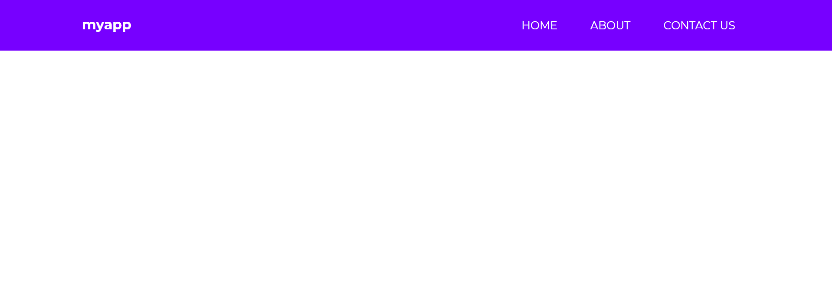

Awesome!

**Angular 7 Routing**

Now that we have a navigation, let's make our little app actually navigation between our components as needed.

Open up **/src/app/app-routing.module.ts** and specify the following contents:

// Other imports removed for brevity

import { HomeComponent } from './home/home.component';

import { AboutComponent } from './about/about.component';

import { ContactComponent } from './contact/contact.component';

const routes: Routes = [

{ path: '', component: HomeComponent },

{ path: 'about', component: AboutComponent },

{ path: 'contact', component: ContactComponent },

];

// Other code removed for brevity

As we can see here, we're defining importing our components and defining an object for each route inside of the **routes** constant. These route objects also accept other properties, which allow you to define URL parameters, but because our app is simple, we won't be doing any of that.

Save this file and try clicking on the links above. You will see that each of the respective component's HTML templating shows up in the **<router-outlet></router-outlet>** defined in *app.component.html*.

This is what the result should look like in the browser at this point:

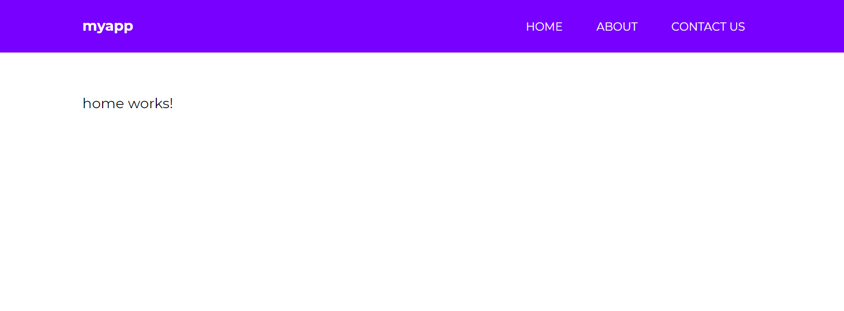

You now know enough about Angular 7 to create a very simple website with routing!  But let's learn more than that.

**Angular 7 Event Binding**

In the next several sections, we're going to use our **/src/app/home** component as a playground of sorts to learn features specific to Angular 7.

One of the most used forms of event binding is the click event. You often need to make your app respond when a user clicks something, so let's do that!

Visit the **/src/app/home/home.component.html** template file and specify the following:

<h1>Home</h1>

<button (click)="firstClick()">Click me</button>

You define an event binding by wrapping the event between (), and calling a method. You define the method in the **home.component.ts** file as such:

export class HomeComponent implements OnInit {

constructor() { }

ngOnInit() {

}

firstClick() {

console.log('clicked');

}

}

Save it, get out the browser console (CTRL+SHIFT+i) and click on the button. The output should show *clicked*. Great!

You can experiment with the other event types by replacing *(click)* with the names below:

(focus)="myMethod()"

(blur)="myMethod()"

(submit)="myMethod()"

(scroll)="myMethod()"

(cut)="myMethod()"

(copy)="myMethod()"

(paste)="myMethod()"

(keydown)="myMethod()"

(keypress)="myMethod()"

(keyup)="myMethod()"

(mouseenter)="myMethod()"

(mousedown)="myMethod()"

(mouseup)="myMethod()"

(click)="myMethod()"

(dblclick)="myMethod()"

(drag)="myMethod()"

(dragover)="myMethod()"

(drop)="myMethod()"

**Angular 7 Class & Style Binding**

Sometimes you may need to change the appearance of your UI from your component logic. There are two ways to do this, through class and style binding.

There are a lot of different methods you can use to control class binding, so we won't cover them all. But I will cover some of the most common use cases.

Let's say that you want to control whether or not a CSS class is applied to a given element. Update the **h1** element in *home.component.html* to the following:

<h1 [class.gray]="h1Style">Home</h1>

Here, we're saying that the CSS class of *.gray* should only be attached to the h1 element if the property *h1Style* results to true. Let's define that in the *home.component.ts* file:

h1Style: boolean = false;

constructor() { }

ngOnInit() {

}

firstClick() {

this.h1Style = true;

}

Let's also define the *.gray* class in this component's scss file:

.gray {

color: gray;

}

Save it, and you can now click on the *click me* button to change the color of the Home title.

What if you wanted to control multiple classes on a given element? You can use *ngClass*. Modify the home component's template file to the following:

<h1 [ngClass]="{

'gray': h1Style,

'large': !h1Style

}">Home</h1>

Then, add the *large* ruleset to the *.scss* file:

.large {

font-size: 4em;

}

Now give it a shot in the browser. *Home* will appear large, but shrink down to the regular size when you click the button. Great!

You can also control appearance by changing the styles directly from within the template. Modify the template as such:

<h1 [style.color]="h1Style ? 'gray': 'black'">Home</h1>

Refresh and give this a shot by clicking the button.

Like *ngClass()* there's also an *ngStyle()* that works the same way:

<h1 [ngStyle]="{

'color': h1Style ? 'gray' : 'black',

'font-size': !h1Style ? '1em' : '4em'

}">Home</h1>

Give this a go! Awesome!

**Angular 7 Services**

Services in Angular 7 allow you to define code that's accessible and reusable throughout multiple components. A common use case for services is when you need to communicate with a backend of some sort to send and receive data.

> ng generate service data

Open up the new service file **/src/app/data.service.ts** and let's create the following method:

// Other code removed for brevity

export class DataService {

constructor() { }

firstClick() {

return console.log('clicked');

}

}

To use this in a component, visit **/src/app/home/home.component.ts** and update the code to the following:

import { Component, OnInit } from '@angular/core';

import { DataService } from '../data.service';

@Component({

selector: 'app-home',

templateUrl: './home.component.html',

styleUrls: ['./home.component.scss']

})

export class HomeComponent implements OnInit {

constructor(private data: DataService) { }

ngOnInit() {

}

firstClick() {

this.data.firstClick();

}

}

There are 3 things happening here:

* We're first importing the *DataService* at the top.
* We're creating an instance of it through dependency injection within the *constructor()* function.
* Then we call the method with *this.data.firstClick()* when the user clicks on the button.

If you try this, you will see that it works as *clicked* will be printed to the console. Awesome! This means that you now know how to create methods that are accessible from any component in your Angular 7 app.

**Angular 7 HTTP Client**

Angular comes with its own HTTP library that we will use to communicate with a fake API to grab some data and display it on our home template. This will take place within the *data.service* file that we generated with the CLI.

In order to gain access to the HTTP client library, we have to visit the **/src/app/app.module.ts** file and make a couple changes. Up until this point, we haven't touched this file, but the CLI has been modifying it based on the generate commands we've issued to it.

Add the following to the imports section at the top:

// Other imports

import { HttpClientModule } from '@angular/common/http';

Next, add it to the *imports* array:

imports: [

BrowserModule,

AppRoutingModule,

HttpClientModule, // <-- Right here

],

Now we can use it in our **/src/app/data.service.ts** file:

import { Injectable } from '@angular/core';

import { HttpClient } from '@angular/common/http'; // Import it up here

@Injectable({

providedIn: 'root'

})

export class DataService {

constructor(private http: HttpClient) { }

getUsers() {

return this.http.get('[**https://reqres.in/api/users**](https://reqres.in/api/users)')

}

}

[**reqres.in**](http://reqres.in/) is a free public API that we can use to grab data.

Open up our *home.component.ts* file and modify the following:

export class HomeComponent implements OnInit {

users: Object;

constructor(private data: DataService) { }

ngOnInit() {

this.data.getUsers().subscribe(data => {

this.users = data

console.log(this.users);

}

);

}

}

The first thing you might notice is that we're placing the code inside of the **ngOnInit()** function, which is a lifecycle hook for Angular. Any code placed in here will run when the component is loaded.

We're defining a **users** property, and then we're calling the *.getUsers()* method and subscribing to it. Once the data is received, we're binding it to our *users* object and also console.logging it.

Give it a try in the browser and you will see the console shows an object that's returned. Let's display it on our home template!

Open up **home.component.html** and specify the following:

<h1>Users</h1>

<ul *ngIf="users">

<li *ngFor="let user of users.data">

<img [src]="user.avatar">

<p>{{ user.first_name }} {{ user.last_name }}</p>

</li>

</ul>

Great! Let's specify some CSS to make this look better in **home.component.scss**:

ul {

list-style-type: none;

margin: 0;padding: 0;

li {

background: rgb(238, 238, 238);

padding: 2em;

border-radius: 4px;

margin-bottom: 7px;

display: grid;

grid-template-columns: 60px auto;

p {

font-weight: bold;

margin-left: 20px;

}

img {

border-radius: 50%;

width: 100%;

}

}

}

View the result in the browser:

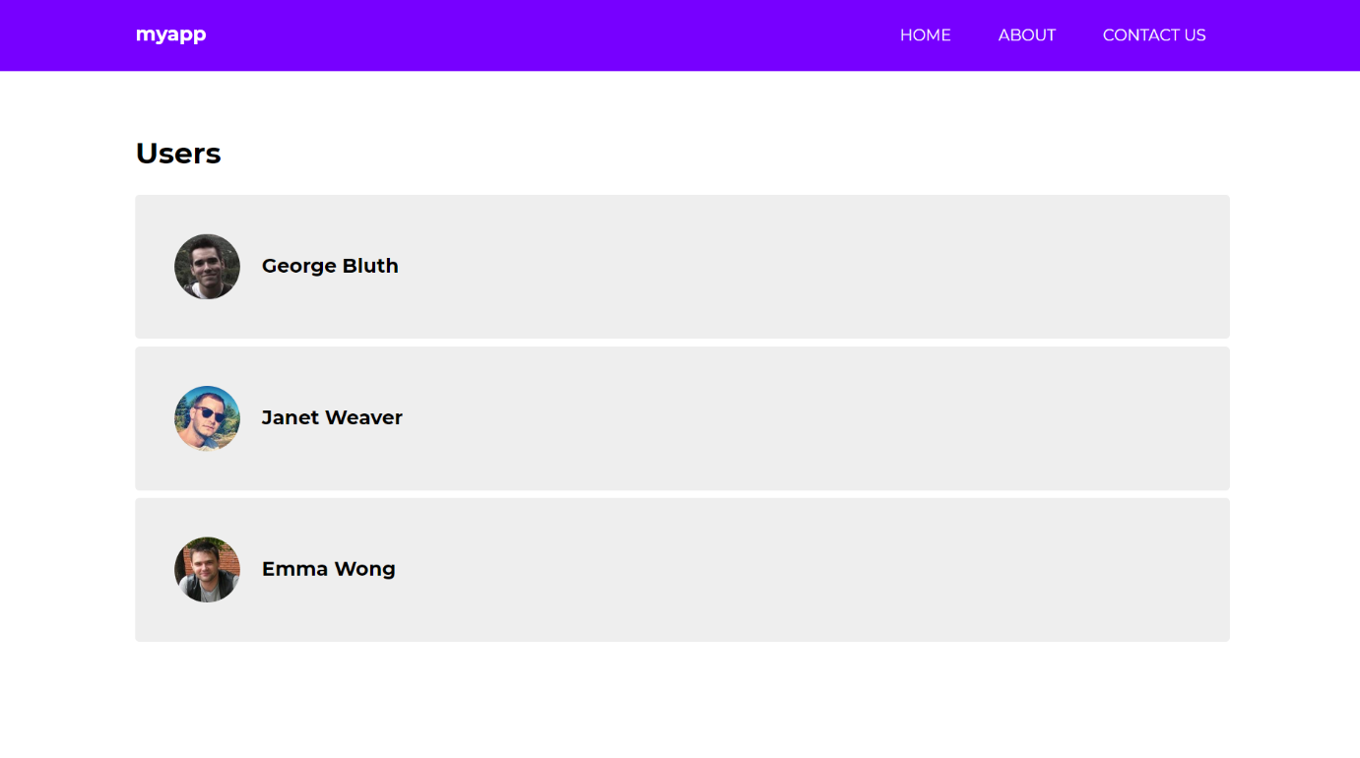

Awesome!

**Angular 7 Forms**

If you recall, we generated a component called **contact**. Let's create a contact form so that you can learn how to use forms in Angular 7.

Angular 7 provides you with two different approaches to dealing with forms: template driven and reactive forms. I'm not going to go into the differences between these two approaches, but reactive forms generally provide you with more control andform validation can be unit tested as opposed to template driven forms.

To get started, we have to visit the **app.module.ts** file and import the Reactive Forms Module:

// other imports

import { ReactiveFormsModule } from '@angular/forms';

// other code

imports: [

BrowserModule,

AppRoutingModule,

HttpClientModule,

ReactiveFormsModule // <- Add here

],

 Next, visit the **contact.component.ts** file and specify the following

import { Component, OnInit } from '@angular/core';

import { FormBuilder, FormGroup, Validators } from '@angular/forms';

@Component({

selector: 'app-contact',

templateUrl: './contact.component.html',

styleUrls: ['./contact.component.scss']

})

export class ContactComponent implements OnInit {

messageForm: FormGroup;

submitted = false;

success = false;

constructor(private formBuilder: FormBuilder) { }

ngOnInit() {

this.messageForm = this.formBuilder.group({

name: ['', Validators.required],

message: ['', Validators.required]

});

}

onSubmit() {

this.submitted = true;

if (this.messageForm.invalid) {

return;

}

this.success = true;

}

}

First, we're importing *FormBuilder, FormGroup, Validators* from @angular/forms.

Then we're setting a few boolean properties that will help us determine when the form has been submitted and if it validation is successful.

Then we're creating an instance of the *formBuilder* in the constructor. We then use this form building to construct our form properties in the *ngOnInit()* lifecycle hook.

We have two properties, *name* and *message*.

Then we created an *onSubmit()* method that will be called when the user submits the form. This is typically where you would call upon a method in the service to communicate with a mail service of sorts.

Next, visit *contact.component.html*:

<h1>Contact us</h1>

<form [formGroup]="messageForm" (ngSubmit)="onSubmit()">

<h5 *ngIf="success">Your form is valid!</h5>

<label>

Name:

<input type="text" formControlName="name">

<div *ngIf="submitted && messageForm.controls.name.errors" class="error">

<div *ngIf="messageForm.controls.name.errors.required">Your name is required</div>

</div>

</label>

<label>

Message:

<textarea formControlName="message"></textarea>

<div *ngIf="submitted && messageForm.controls.message.errors" class="error">

<div *ngIf="messageForm.controls.message.errors.required">A message is required</div>

</div>

</label>

<input type="submit" value="Send message" class="cta">

</form>

<div *ngIf="submitted" class="results">

<strong>Name:</strong>

<span>{{ messageForm.controls.name.value }}</span>

<strong>Message:</strong>

<span>{{ messageForm.controls.message.value }}</span>

</div>

Baked in here is a full form with validation. It also prints out the form values beneath it when the form has been submitted.

Let's update the css for the component to make it look decent:

label {

display: block;

input, textarea {

display: block;

width: 50%;

margin-bottom: 20px;

padding: 1em;

}

.error {

margin-top: -20px;

background: yellow;

padding: .5em;

display: inline-block;

font-size: .9em;

margin-bottom: 20px;

}

}

.cta {

background: #7700FF;

border: none;

color: white;

text-transform: uppercase;

border-radius: 4px;

padding: 1em;

cursor: pointer;

font-family: 'Montserrat';

}

.results {

margin-top: 50px;

strong {

display: block;

}

span {

margin-bottom: 20px;

display: block;

}

}

Save it, and the result in the browser should look like this!

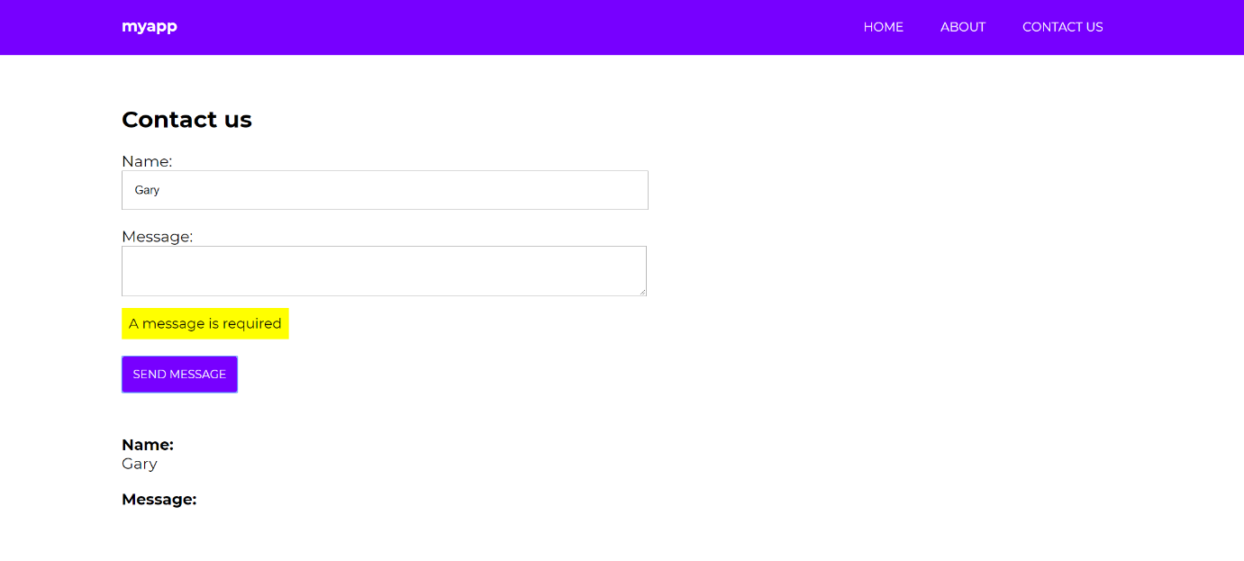

Awesome!